

SEGMENTZ, INC. designs best in class logistics services that are customized to meet our client’s individual needs and flexible enough to cope with an ever changing business environment. We analyze our customer’s unique supply-chain parameters, design a strategic plan, and implement an end to end solution utilizing experienced personnel and technology to achieve desired results.

SEGMENTZ, INC. is publicly traded on NASDAQ OTC-BB under the symbol SEGZ.

CAPABILITIES AND SERVICE OFFERINGS

SEGMENTZ, INC. is committed to providing excellent communication and continuous improvement to customer service procedures. Segmentz offers a 24 hour, seven day a week call center allowing the customer immediate status of shipments in transit. Shipment tracking is available for customers via a custom designed web site and carrier links. On-time percentage tracking and service failure reports are also available.


Nationwide Truckload and Less-than-truckload Service
Segmentz arranges truckload transportation with dedicated company equipment, owner operator fleet and extensive agent partners throughout all 48 states.


Time-definite Transportation
Segmentz offers its customers time-definite ground transportation of cargo as a cost effective, reliable alternative to air transportation. Segmentz provides daily scheduled transportation between airport locations in the Southeast and Midwest.


Dedicated Delivery Service
Segmentz provides dedicated equipment, facilities and staffing required to become a seamless extension of the customer’s distribution network.


Third-Party Logistics Service
Segmentz can provide a complete end to end, technology driven solution to our customers. Strategic alliances with industry leaders allow Segmentz to provide a wide array of services which can be customized to meet the customer’s individual needs.


Warehouse Management
Segmentz provides a comprehensive network of automated facilities designed to provide an outsourcing option to manufacturers, retailers, distributors and eBusinesses. The Warehouse Management System (WMS) is completely automated enabling Segmentz to create a “virtual warehouse” to accurately control, receive, shelve, inventory, pick, pack and ship products for its customers. There over 500,000 square feet of space with additional multi-tier rack capacity is secure and bonded.



Reverse Logistics
Many logistics solutions providers only offer their services from the warehouse to the end customer (for example, after the product has been purchased and received from the vendor). Segmentz can offer to handle the customer’s product from the vendor all the way to the end customer and even handle any needs after the product reaches its final destination or dispose of the product.

CURRENT LOCATIONS

Corporate Headquarters

SEGMENTZ, INC.
18302 Highwoods Preserve Parkway
Suite 100
Tampa, FL 33647

Regional Terminals

Atlanta, GA (ATL)  10 Southwoods Parkway, Ste 200  Atlanta, GA 30349  Phone (800) 950-5097  Local (404) 361-0688  Fax (404) 361-1303 | Lexington, KY (LEX)  951 Air Freight Drive  Lexington, KY 40511  Phone (800) 950-0599  Local (859) 381-0034  Fax (859) 455-8744 | Louisville, KY (SDF)  2100 South 9th Street  Louisville, KY 40208  Phone (800) 950-0596  Fax (502) 637-6897
Chicago, IL (ORD)  2751 Old Higgins Road  Elk Grove Village, IL 60007  Phone (800) 950-0595  Local (847) 718-0595  Fax (847) 718-1004 | Knoxville, TN (TYS)  1525 Sterchi Street  Knoxville, TN 37921  Phone (800) 950-0598  Local (865) 521-7641  Fax (865) 521-6091 | Cincinnati, OH (CVG)  1488 Cox Avenue  Erlanger, KY 40209  Phone (800) 950-0597
Evansville (EVV)  15000 B U.S. Hwy. 41 North  Evansville, IN 47725  Phone (866) 267-2706  Local (812) 253-5234  Fax (812) 253-5235 | Miami (MIA)  7270 NW 35 Terrace  Miami, Florida 33144  Phone (305) 499-9219  Fax (305) 499-9315 | West Palm Beach (PBI)  1650 Latham Road  Palm Beach, Florida  Phone (561) 687-7663
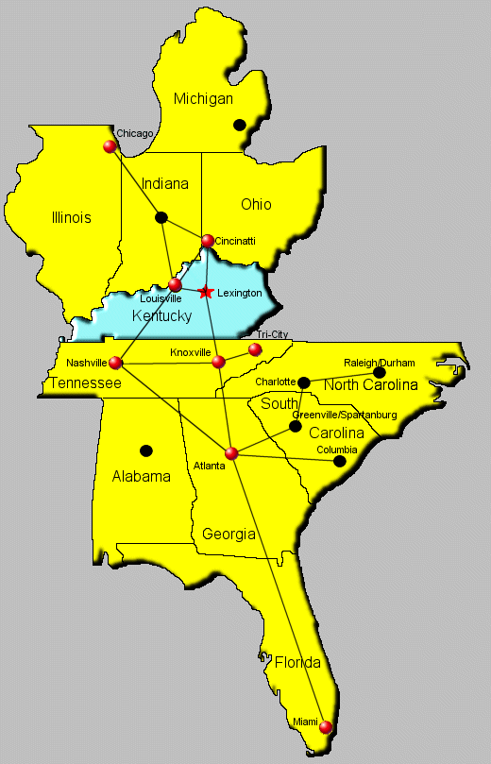
- Indicates future SEGMENTZ locations

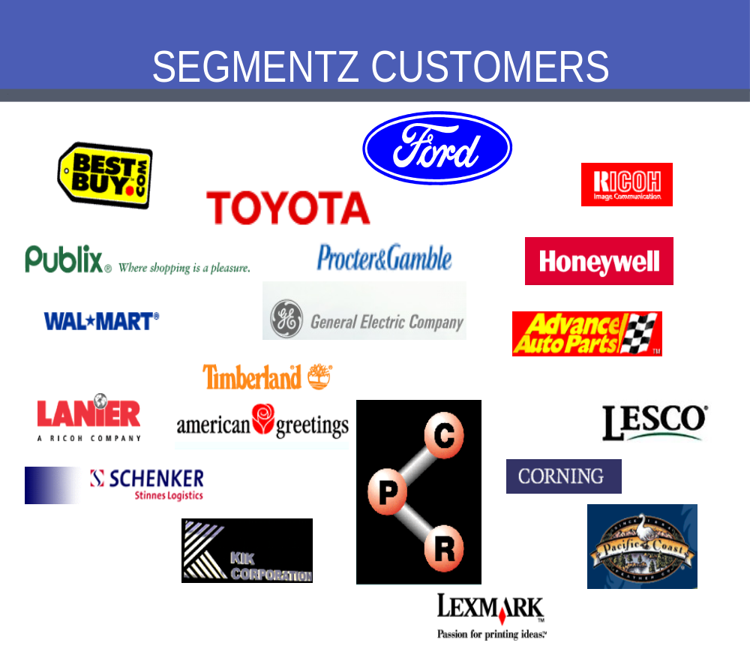


SEGMENTZ, INC. has a diverse customer base with wide ranging transportation and logistics needs. Our goal at Segmentz is to become a seamless extension of our customer’s supply-chain utilizing advanced technology (fully integrated and real-time), industry expertise and unparalleled customer support to provide customized solutions.

